ATS Engine Architecture Image Pack

ARCH-HLD-001 – System Overview
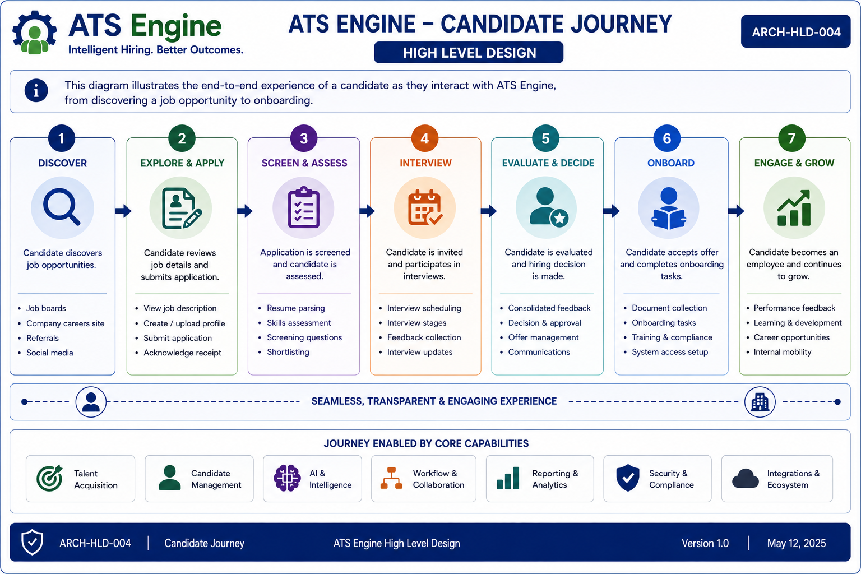

Breakdown
This section documents the purpose, components, workflow, key decisions, business value, dependencies, assumptions, risks, and future enhancements for System Overview. Replace this text with the detailed explanation corresponding to the final approved architecture image.

ARCH-HLD-002 – ATS Scoring Engine


Breakdown
This section documents the purpose, components, workflow, key decisions, business value, dependencies, assumptions, risks, and future enhancements for ATS Scoring Engine. Replace this text with the detailed explanation corresponding to the final approved architecture image.

ARCH-HLD-003 – Routing Decision Engine


Breakdown
This section documents the purpose, components, workflow, key decisions, business value, dependencies, assumptions, risks, and future enhancements for Routing Decision Engine. Replace this text with the detailed explanation corresponding to the final approved architecture image.

ARCH-HLD-004 – Data Model Architecture


Breakdown
This section documents the purpose, components, workflow, key decisions, business value, dependencies, assumptions, risks, and future enhancements for Data Model Architecture. Replace this text with the detailed explanation corresponding to the final approved architecture image.

ARCH-HLD-005 – Candidate Journey


Breakdown
This section documents the purpose, components, workflow, key decisions, business value, dependencies, assumptions, risks, and future enhancements for Candidate Journey. Replace this text with the detailed explanation corresponding to the final approved architecture image.

ARCH-HLD-006 – Application Tracking Workflow


Breakdown
This section documents the purpose, components, workflow, key decisions, business value, dependencies, assumptions, risks, and future enhancements for Application Tracking Workflow. Replace this text with the detailed explanation corresponding to the final approved architecture image.

ARCH-HLD-007 – Reporting & Analytics


Breakdown
This section documents the purpose, components, workflow, key decisions, business value, dependencies, assumptions, risks, and future enhancements for Reporting & Analytics. Replace this text with the detailed explanation corresponding to the final approved architecture image.

ARCH-HLD-008 – Cover Letter Generation


Breakdown
This section documents the purpose, components, workflow, key decisions, business value, dependencies, assumptions, risks, and future enhancements for Cover Letter Generation. Replace this text with the detailed explanation corresponding to the final approved architecture image.

ARCH-HLD-009 – Automation Architecture


Breakdown
This section documents the purpose, components, workflow, key decisions, business value, dependencies, assumptions, risks, and future enhancements for Automation Architecture. Replace this text with the detailed explanation corresponding to the final approved architecture image.

ARCH-HLD-010 – System Architecture


Breakdown
This section documents the purpose, components, workflow, key decisions, business value, dependencies, assumptions, risks, and future enhancements for System Architecture. Replace this text with the detailed explanation corresponding to the final approved architecture image.

ARCH-HLD-011 – Integration Architecture


Breakdown
This section documents the purpose, components, workflow, key decisions, business value, dependencies, assumptions, risks, and future enhancements for Integration Architecture. Replace this text with the detailed explanation corresponding to the final approved architecture image.

ARCH-HLD-012 – Data Architecture


Breakdown
This section documents the purpose, components, workflow, key decisions, business value, dependencies, assumptions, risks, and future enhancements for Data Architecture. Replace this text with the detailed explanation corresponding to the final approved architecture image.

